Exercises – Semantic Tableaux Method
Exercise 1
Using the semantic tableaux method decide what kind (consistent, inconsistent, valid) of formula is 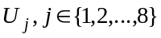.
If is consistent, find all its models.
1.;
2.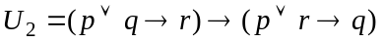;
3.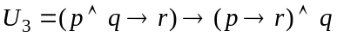;
4.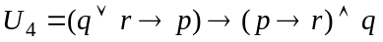;
5.;
6.;
7.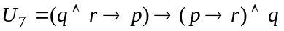;

Exercise 2
Prove that the following formulas are tautologies using the semantic tableaux method:
1. distribution of ’’ over ’’: ;
2. separation of the premises law: 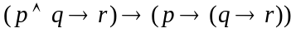;
3. distribution of ’’ over ’’: ;
4. distribution of ’’ over ’’: ;
5. reunion of the premises law: 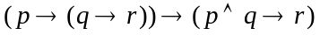;
6. distribution of implication:;
7. permutation of the premises law: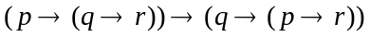;
8. distribution of ’’ over ’’: .

Exercise 3
Using the semantic tableaux method, decide whether the following logical consequences hold or not.
If a logical consequence does not hold find an anti-model of it.
1.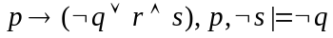
2.
3.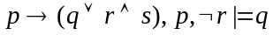
4.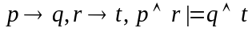
5.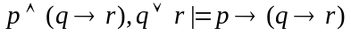
6.
7.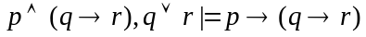
8.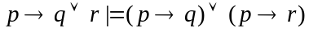

Exercise 4
Write all the anti-models of the propositional formulas 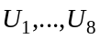 using the semantic tableaux method.
1.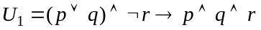;
2.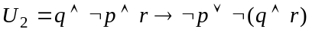;
3.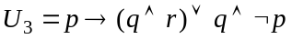;
4.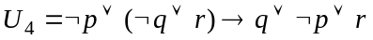;
5.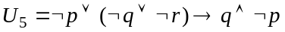;
6.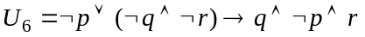;
7.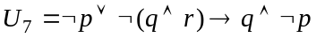;
Exercise 5.
Check whether the conclusion  is a logical consequence of the set of hypotheses using
the semantic tableaux method.
Hypotheses:
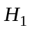. All hummingbirds are richly colored.
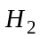. No large birds live on honey.
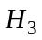. Birds that do not live on honey are dull in color.
Conclusion: C. All hummingbirds are small.

Exercise 6
Using the semantic tableaux method, prove the following properties in predicate logic:
1.’’ is semi-distributive over ’’:
a) and
b)

2.’’ is semi-distributive over ’’:
a) and
b)

3.’’ is semi-distributive over ’’:
a) and
b)

4.’’ is semi-distributive over ’’:
a) and
b)

5. a)and
b)
6.’’ is distributive over ’’
- “−>”
- “<−“

7.’’ is distributive over ’’
- “−>”
- “<−“

